**Project Title:** Heart Disease Analysis **Project Design Phase-I** - **Solution Fit Template Team ID: LTVIP2026TMIDS73244**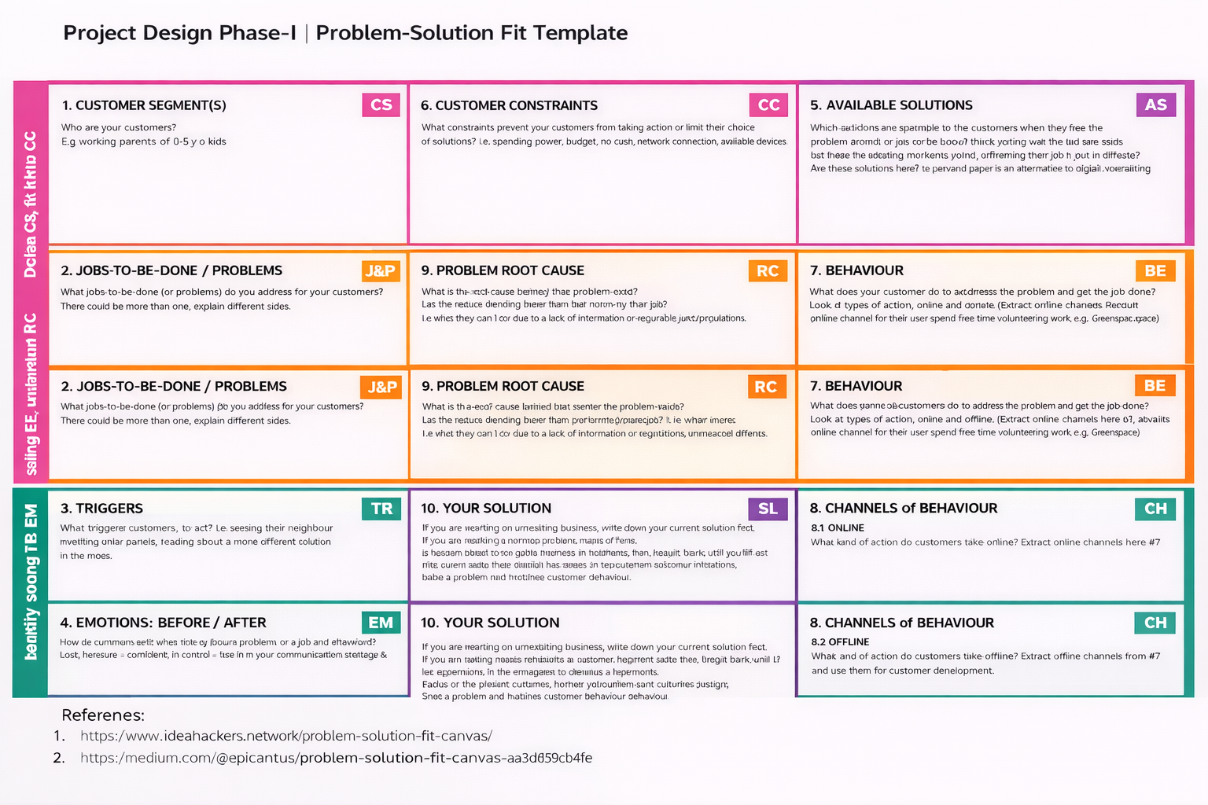

**Focus on J&P, tap into BE, understand RC**